**dLab: ELK Setup**

Go to this web site **https://www.elastic.co/downloads/.** Or to download from here

**https://artifacts.elastic.co/downloads/elasticsearch/elasticsearch-7.4.2-**

**amd64.deb**

and download all the package DEB.

Note: Download only the **DEB** package because this package automatically sets the settings on the machine.

If you do not download this package you will need to set everything yourself.

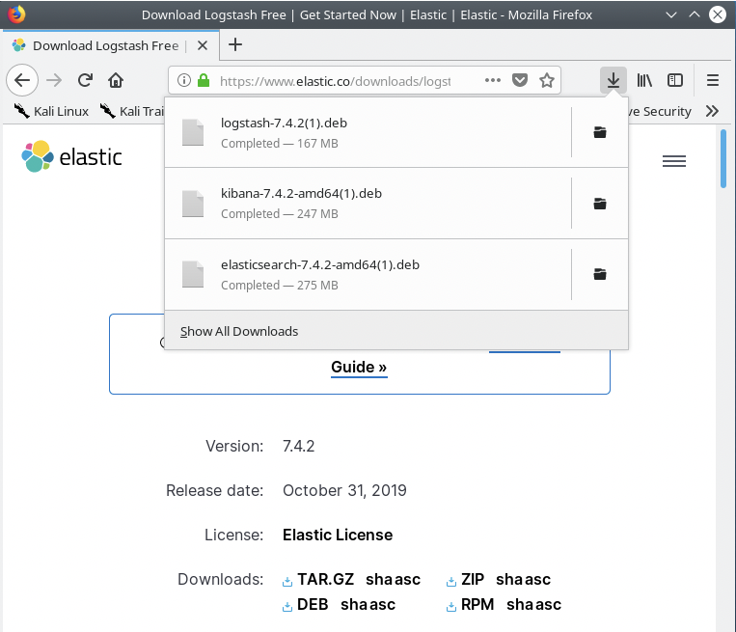

Use command **#dpkg –I**Extract **Elasticsearch**, **kibana**, **logstash**.

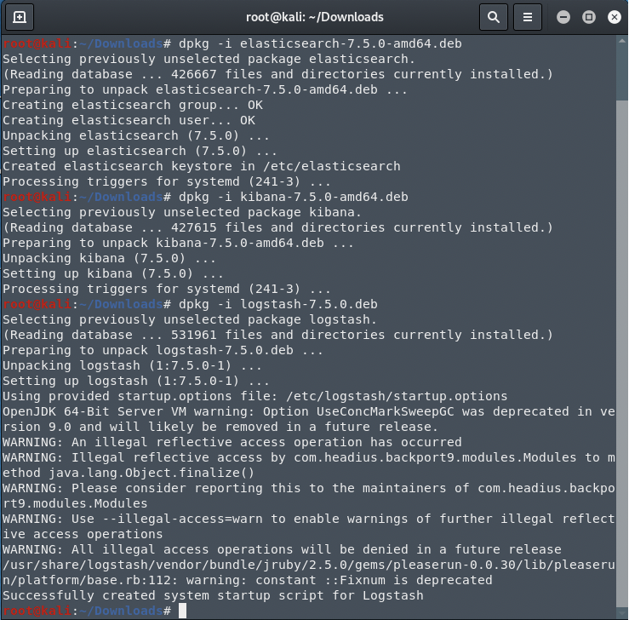

After extracting, make sure the settings are correct before starting the service. You will need to verify the settings in three files in the following paths, but do it in the next order and only then run the service.

• step 1: **#nano /etc/kibana/kibana.yml** = Here you enter your computer's address or (localhost)to allow access to Kibana, and save.

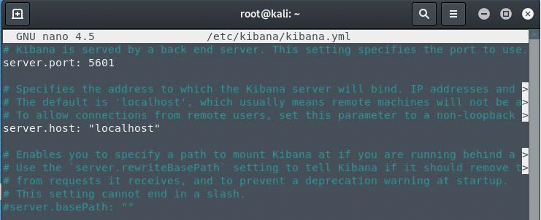

Step 2: start the service **elasticsearch** first and then service kibana and then logstash. Command :

A) Serviceelasticsearchstart. B) Servicekibanarestart.  
C) Servicelogstashstart.

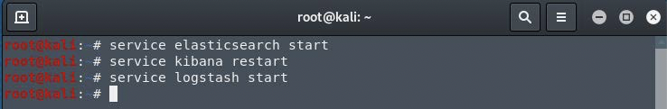

After you start the services, open Firefox and type in the URL: “localhost:5601” check if the site of kibana works

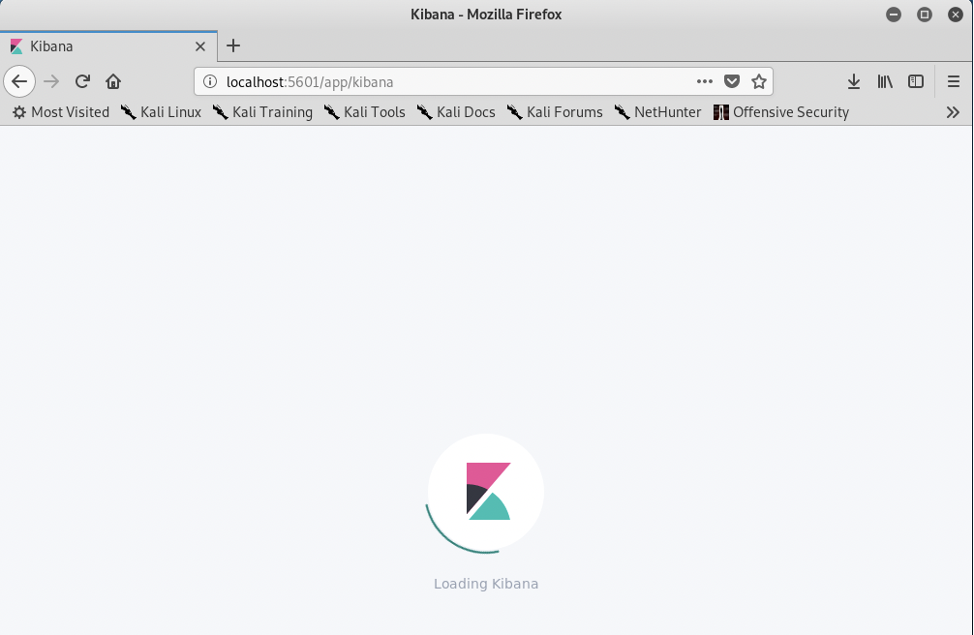

• Step3: stop the service elasticsearch whit command: “service elasticsearch stop“

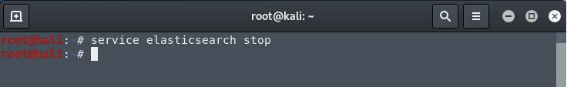

and configure the file yml  
nano /etc/elasticsearch/elasticsearch.yml Here you set the access address to Elastic.

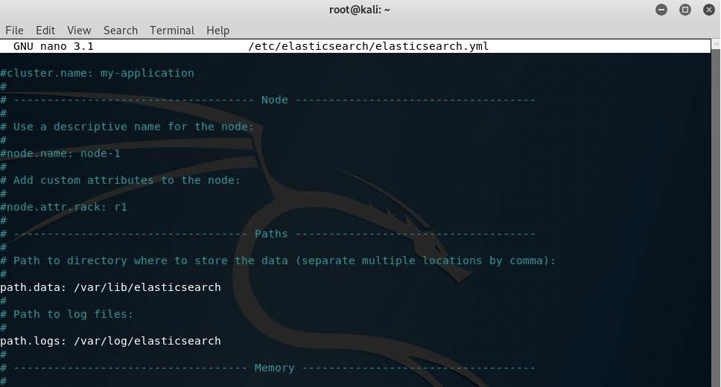

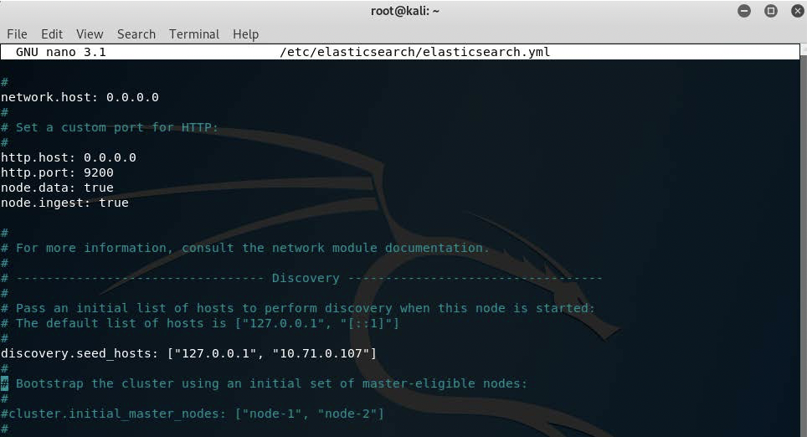

After you finish to configure the yml file restart the service

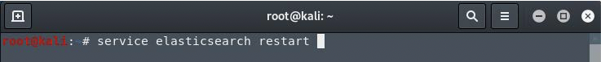

Step 4: **#nano /etc/logstash/logstash-sample.conf** =  
Here, you don't need to change anything, just make sure the settings you have match the settings in

the image

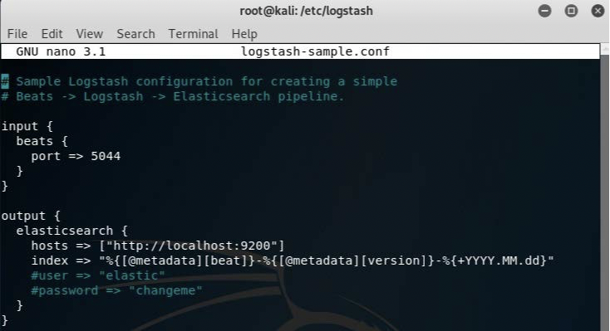

Login to kibana site



Login to kibana site

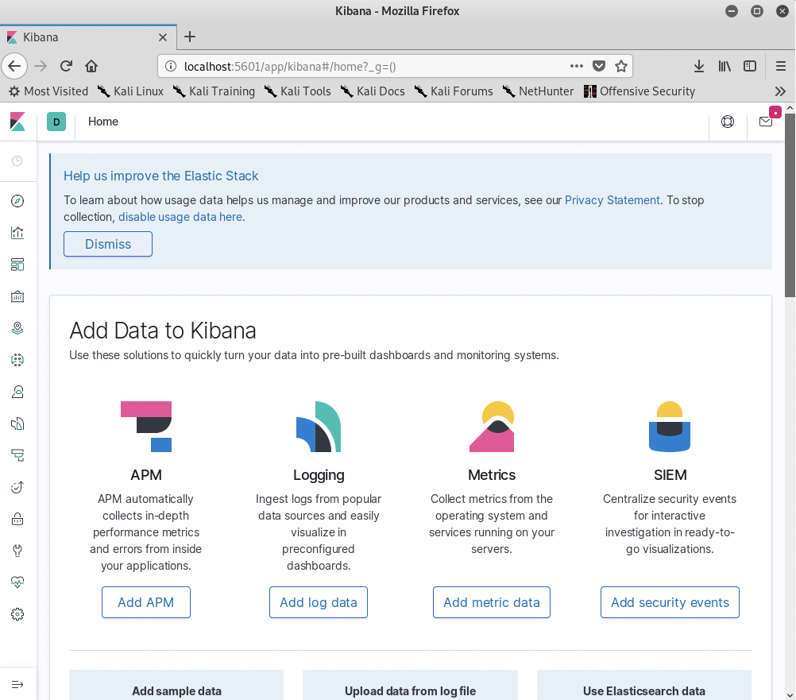

Now we will install **metricbeat** on our system so the ELK can get DATA and we can build a dashboard.

Use Command to download:

**#curl -L -O https://artifacts.elastic.co/downloads/beats/metricbeat/metricbeat-7.4.2-amd64.deb**

or you can to download it

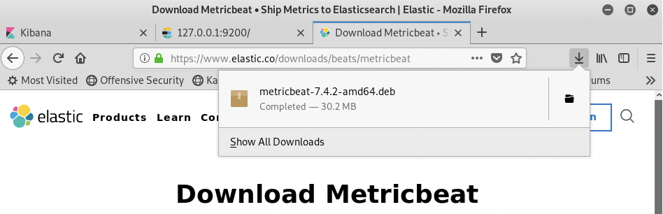

Extract: **#dpkg -i metricbeat-7.4.2-amd64.deb**

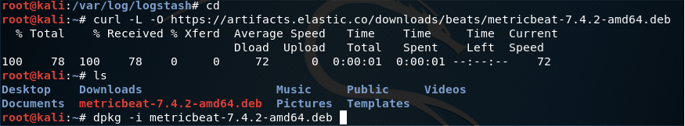

After

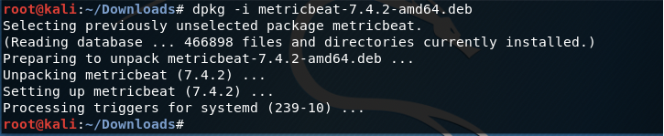

**#nano /etc/metricbeat/metricbeat.yml**

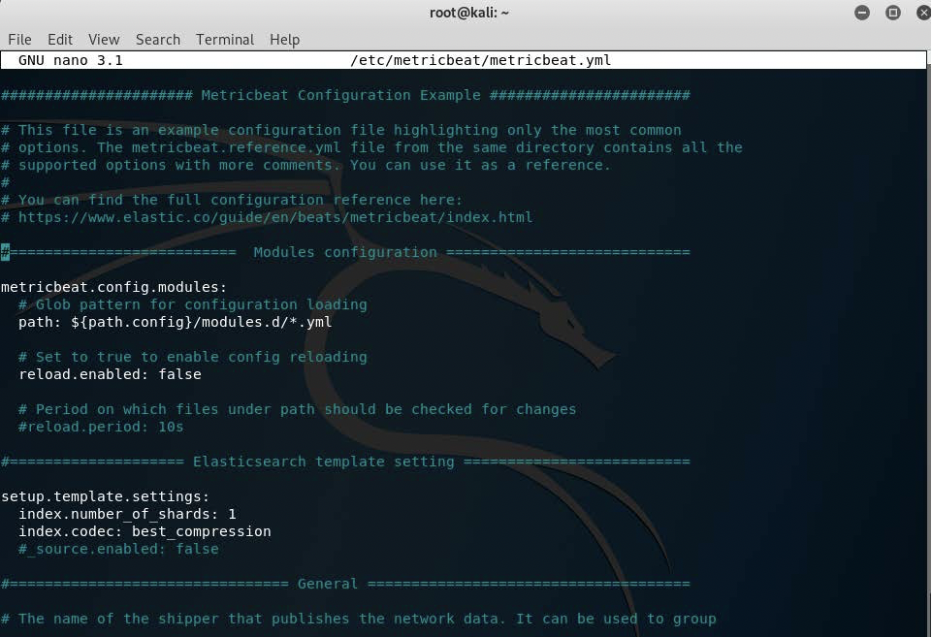

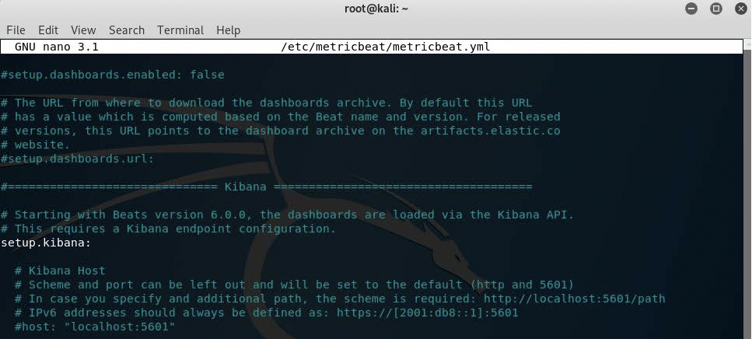

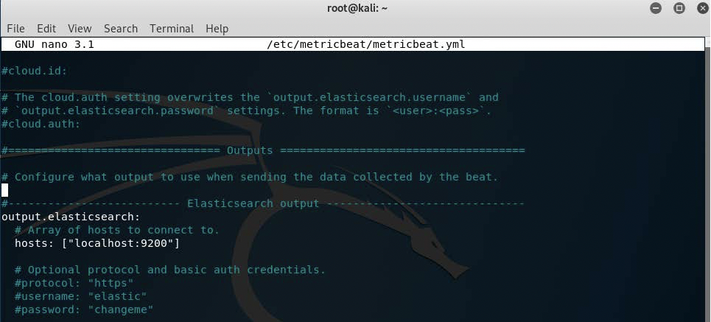

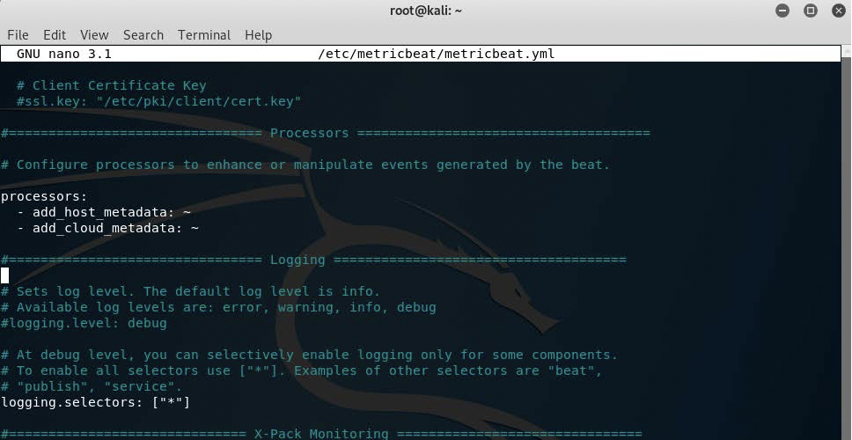

Start the services elasticsearch kibana logstash and metricbeat.

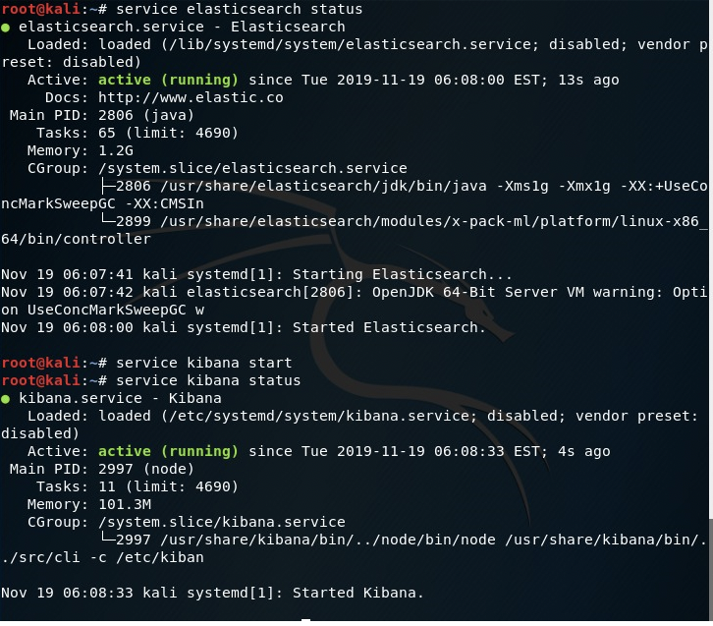

*** collecting logs

After we did the installation and made sure everything was running. We will sign in Kibana and start collecting information

Now add data from localhost (metricbeat) to kibana.  
Open the browser and type 127.0.0.1:5601 press enter in the side navigation, click Management Below Kibana click on index patterns◊Create index pattern.

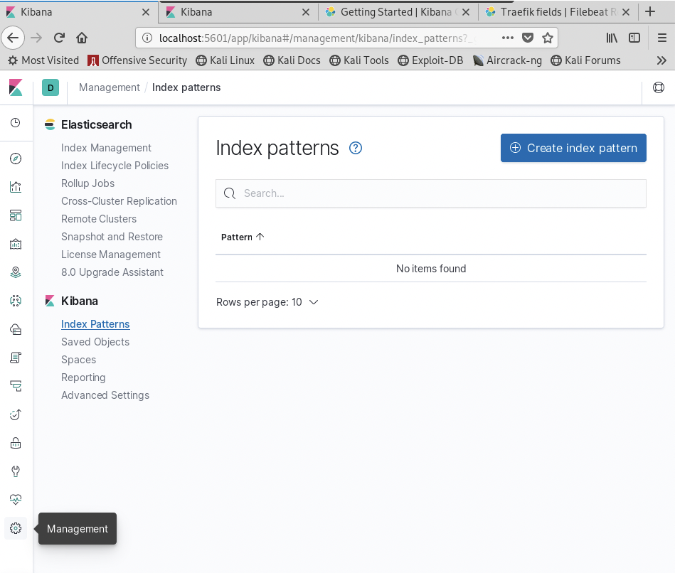

Now you can see 1 or 2 indices do you have,

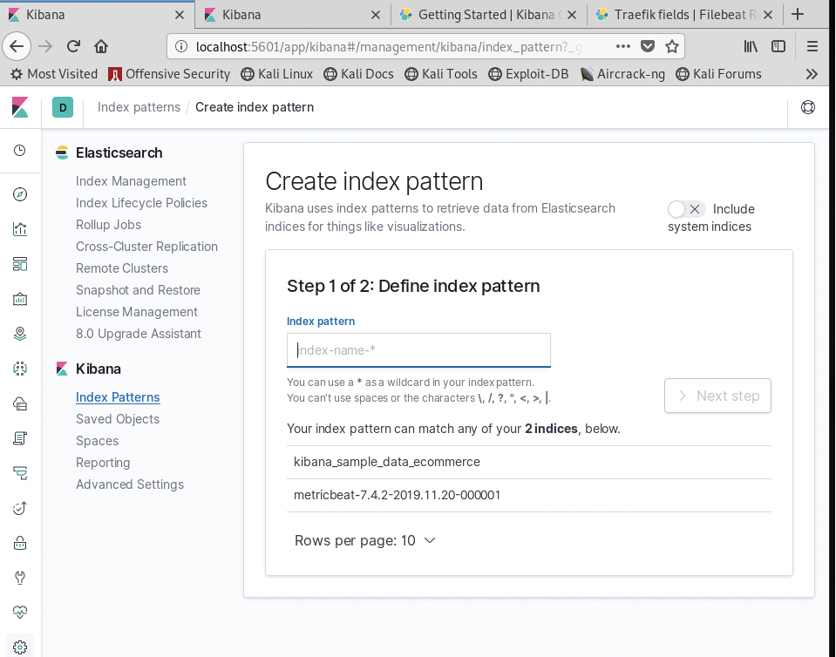

Step 1: in the field index pattern write Name **metricbeat-localhost,\*** and press >Next step

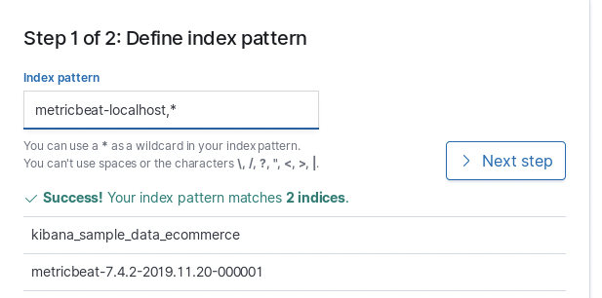

Step 2: you defined metricbeat-localhost,* as youe index pattern. now you can specify some settings before we create it.

Select @timestamp and press on -> Create index pattern

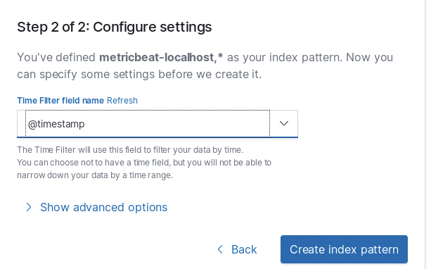

Navigate to Discover and automatically you can see date from your local host

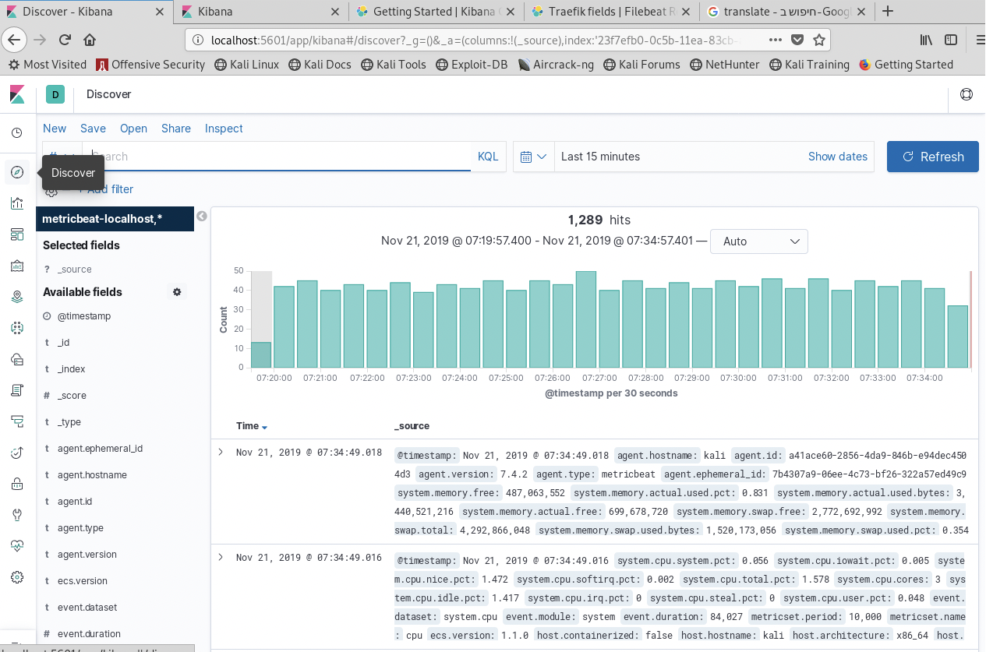

Note: Also you can install beats on windows Building a dashboard in kibana

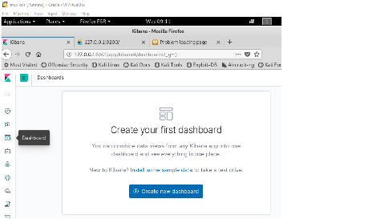

Click Add. And here you choose the type of tables you want to see in your dashboard.

install **metricbeat** on windows  
step 1 : Download the **winlogbeat** Windows zip file from https://www.elastic.co/downloads/beats/winlogbeat step2: Extract the contents of the zip file into C:\.  
**Step 3: .**

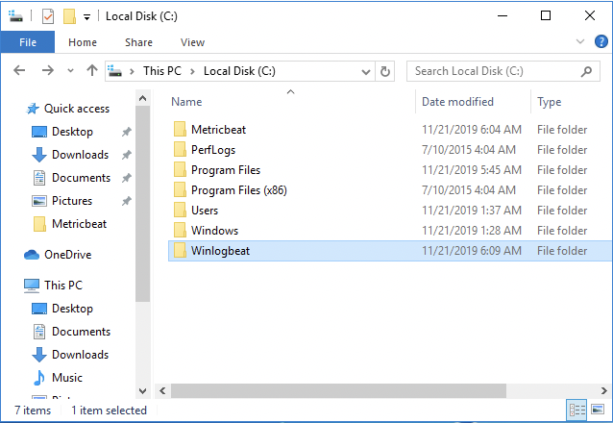

Step4:

Step 5: From the PowerShell prompt, run the following commands to install Metricbeat as a Windows service

**A:** navigate **C:\winlogbeat->  
B:** run command: **Set-ExecutionPolicy Unrestricted** and press **y** (yes) **C:** run command **.\install-service-winlogbeat.ps1**

Open a PowerShell prompt as an Administrator (right-click the PowerShell icon and select Run As



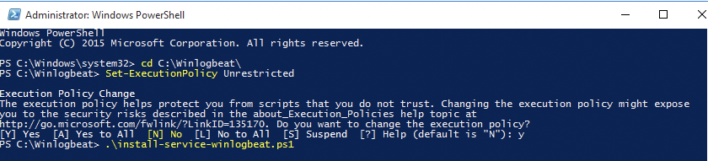

**D:** configure the file winlogbit.yml (you can open this file whit notepad++ )

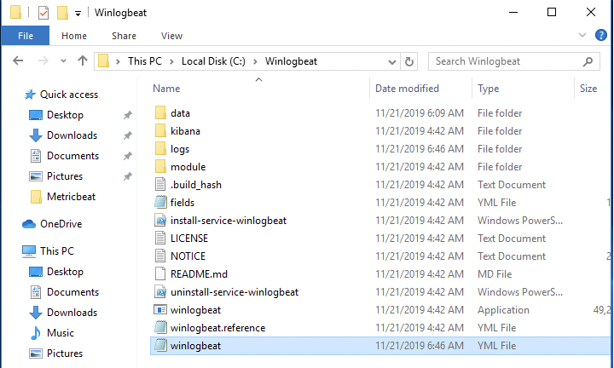

What did we need to configure in file winlogbeat? Her we select the logs we want to send like you see **Applications, system, security**.

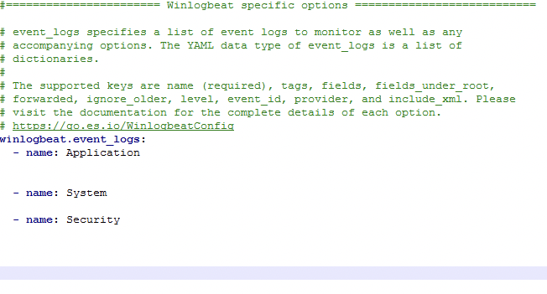

**Next:** in the line on kibana set the IP address on your server

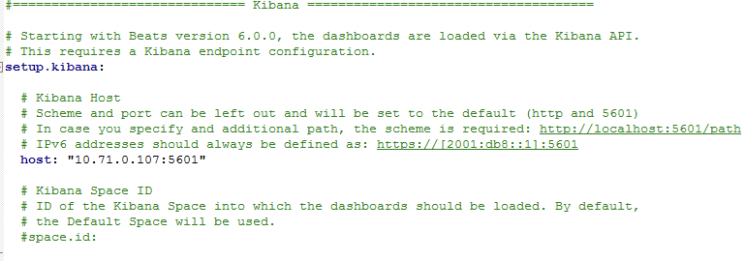

**Next:** in the line on elasticsearch set the IP address on your server.

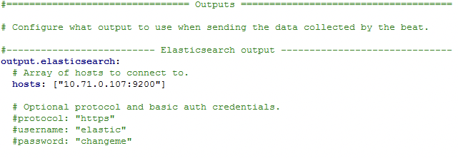

**Next:** save the change.  
**E**: Back to the Powershell and setup the configuration by command **C:\winlogbeat> .\winlogbeat.exe setup**

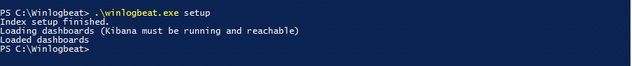

And start the service by command: **start-service winlogbeat**New login to kibana from the windows like **your kibana IP Address:5601**